**HTML and CSS Tasks**

* **GitHub Link -** [**Devesh Jangir_task1**](https://github.com/imdevesh01/rg-assignments/tree/task1HtmlAndCssAssignment/task1)
* **Files -**

**Index.html**

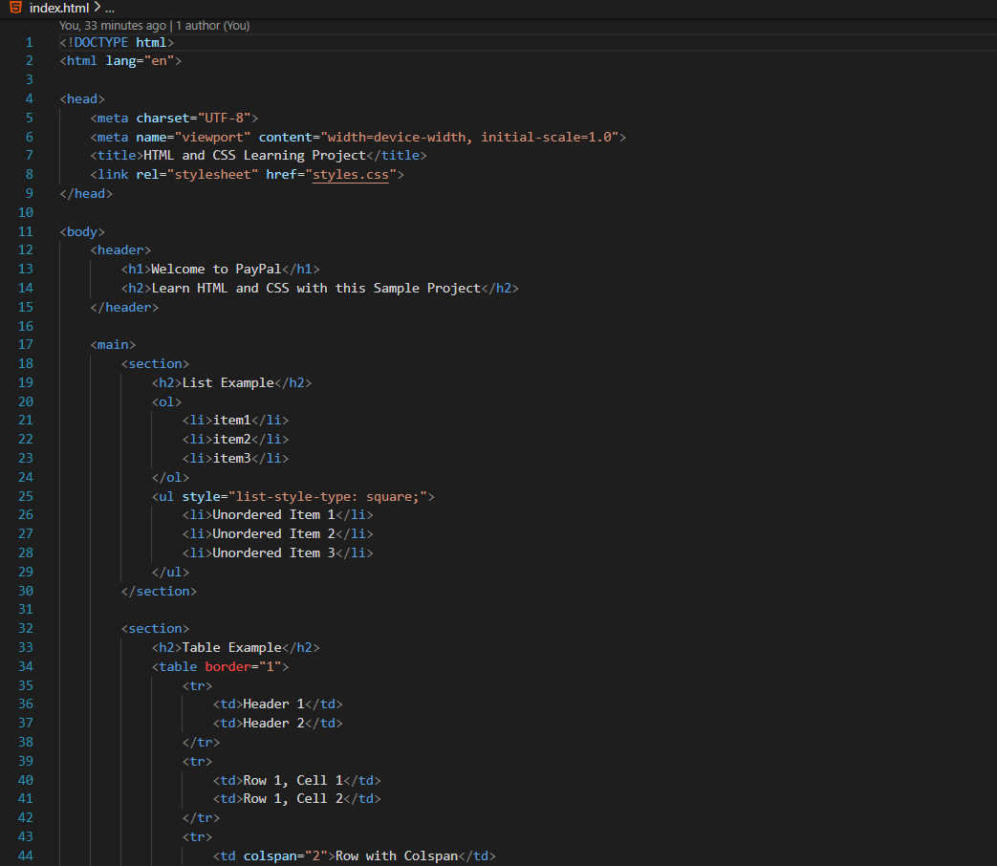

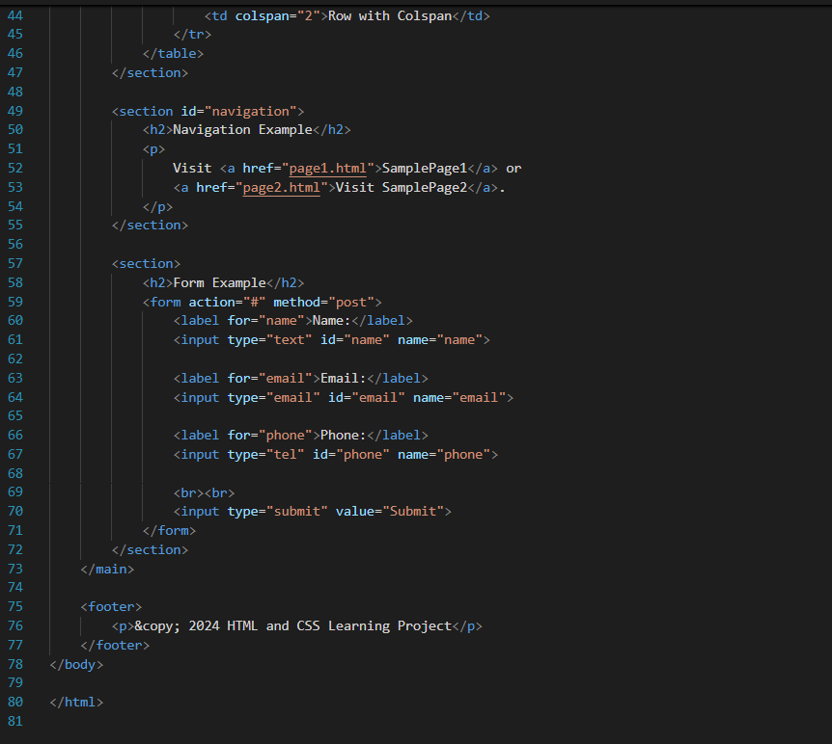

**Page1.html**

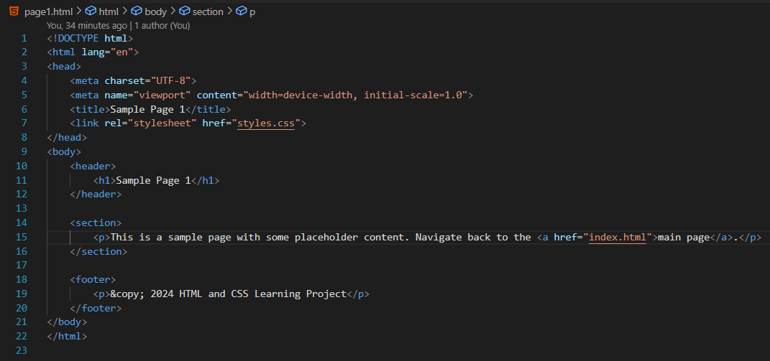

**Page2.html**

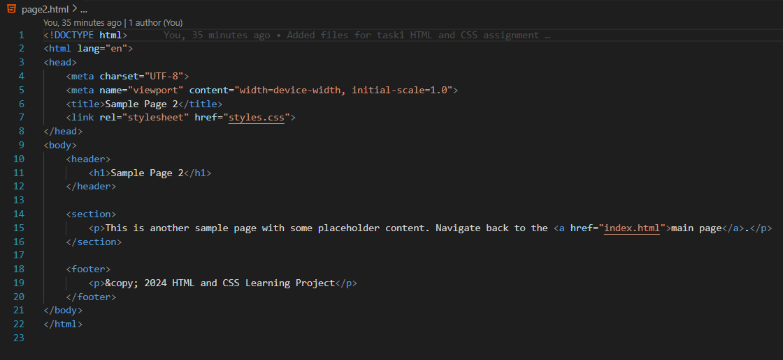

**Styles.css**

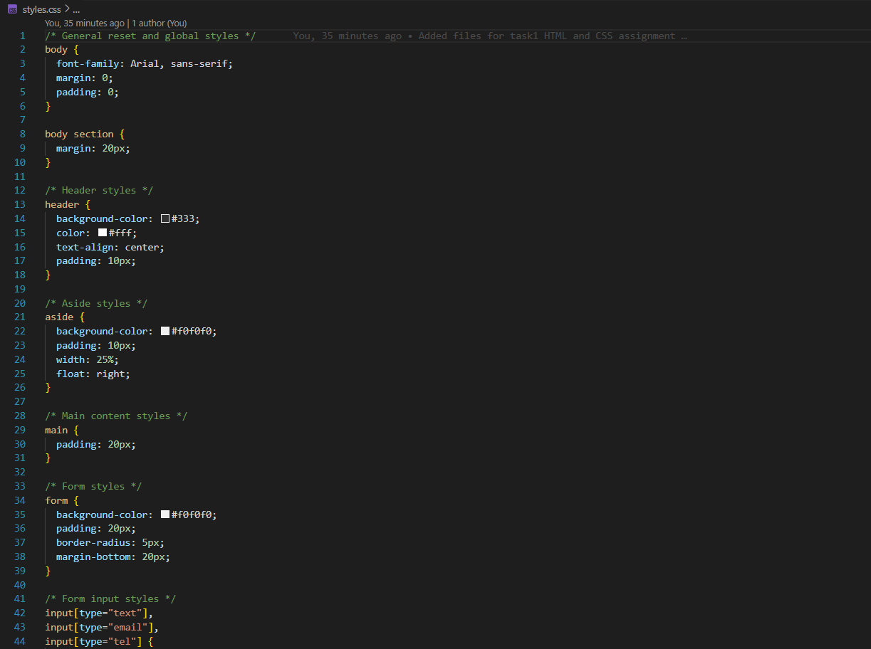

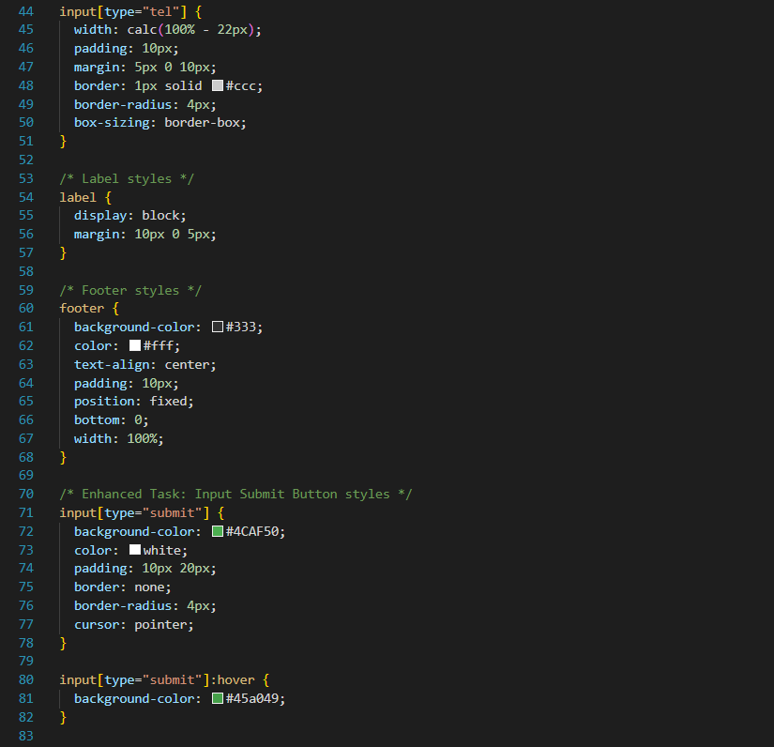

* **Code Result/Output -**

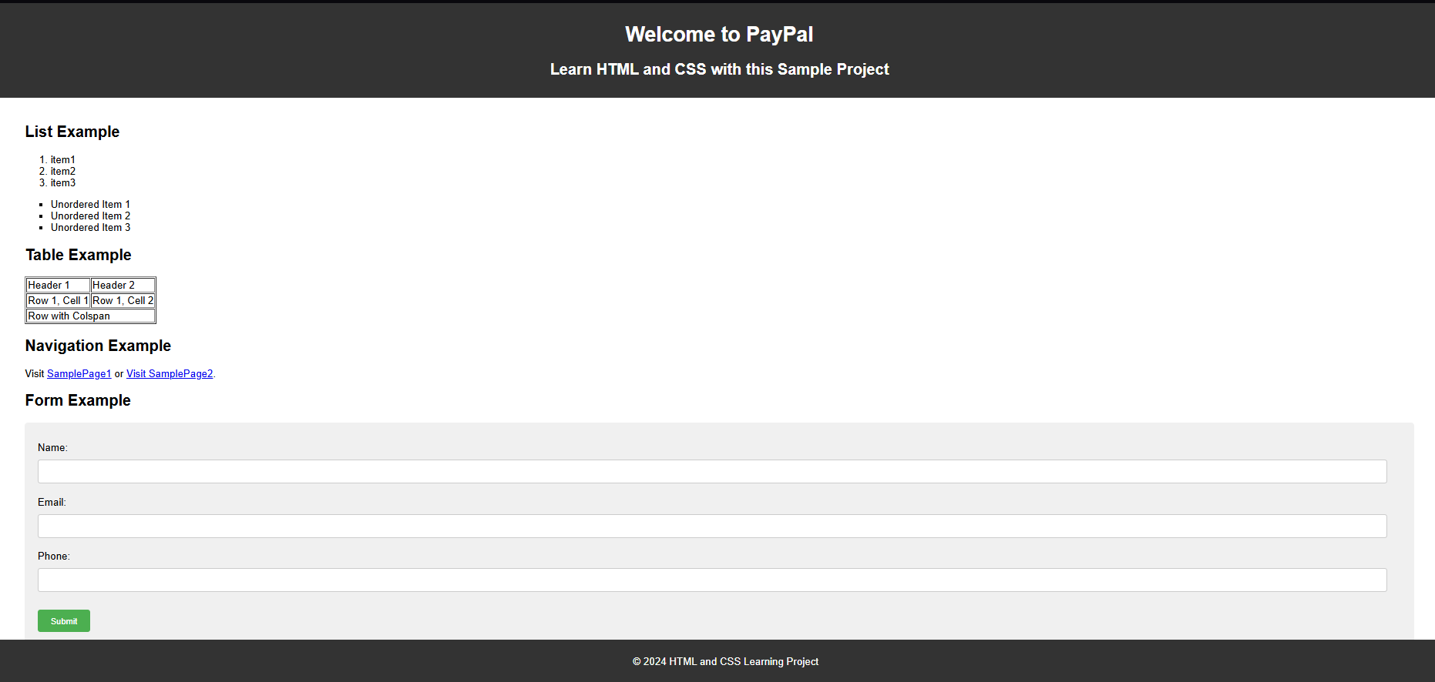

**Git and IntelliJ Tasks**

Explain the following questions in two simple sentences.

1. What is the use of the git add command?  
 **Ans:** The git add command is used to stage changes so they can be included in the next commit. It tells Git which files or updates we want to track and save.

2. Write the command to create a branch “feature-group”.  
 **Ans:** To create a new branch named “feature-group”, use the command: **git branch feature-group**. This creates a separate line of development from the current branch.

3. What is a pull request? Write the steps involved in creating a pull request.  
 **Ans:** A pull request is a way to propose our code changes and request that they be merged into another branch, usually the main one.  
 **Steps:** First push code → Go to GitHub → Click “Compare & pull request” → Add a title and description → Click “Create pull request”.

4. How do you add collaborators?  
 **Ans:** Open GitHub repository → Click on "Settings" → Go to the "Collaborators" section. Enter the collaborator's GitHub username and send them an invitation.

5. What is the command used to commit our changes in GitHub repo?  
 **Ans:** Use the command **git commit -m "your message"** to save staged changes with a description. This records changes in the local Git history.

6. Create a github account and repository to save all your assignment tasks. Example repository name: rg-assignments  
 **Ans:** 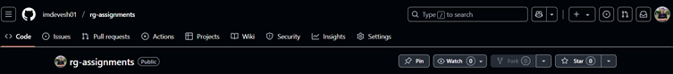

1. Create a branch called feature-java(you can use it later to push all your java related tasks to this branch)

**Ans:**

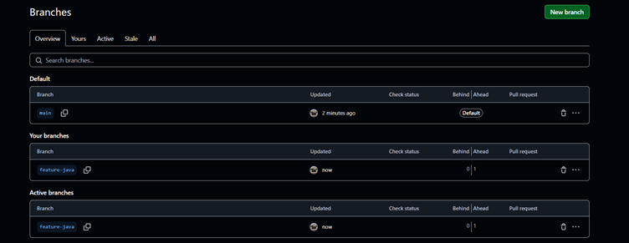

1. Install IntelliJ IDE. Create a simple java project displaying “Hello World!!”and share the screenshot.

**Ans:**

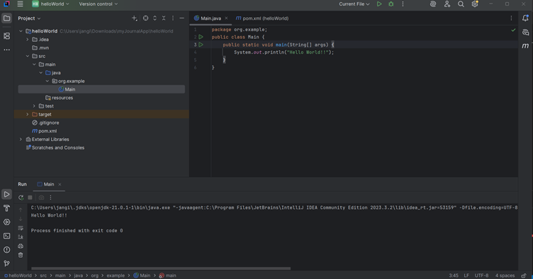

9. In IntelliJ IDE, explore the shortcut keys for the following

a. To run the project

b. To select a line

c. To comment/uncomment a line

d. To delete a line

**Ans: Executed**

| **Task** | **Shortcut (Windows)** |
| --- | --- |
| To run the project | Shift + F10 |
| To select a line | Shift + End or Home |
| To comment/uncomment a line | Ctrl + / |
| To delete a line | Ctrl + Y |